Planning the skeleton

Real use-cases of the skeleton model

Use-case diagram
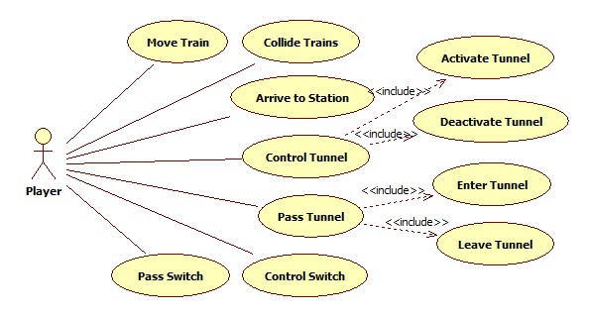

Use-case descriptions

Use-case name | Move Train
Short textual description | Engine of the train moves forward to the next field and pulls cars behind
Actors | Player
Main success scenario | 1. The train moves forward
Alternate scenario | 1.A.1 If direction that the train is facing is free, train moves forward
Alternate scenario | 1.B.1 If there is a switch in front of a train, train moves according to the switch
Alternate scenario | 1.C.1 If there is a tunnel entry point in front of the train, train enters the tunnel
Alternate scenario | 1.D.1 If there is a dead end in front of the train player loses the round
Alternate scenario | 1.E.1 If there is another train in front of the train, then trains collide and player loses the round

Use-case name | Collide Trains
Short textual description | Two engines of the trains move to the same field and collide
Actors | Player
Dialog, scenario | 1. Two engines moving in opposite directions enter the same field. Collision happens and the player loses the round.

Use-case name | Arrive to Station
Short textual description | Train arrive to the Station field
Actors | Player
Dialog, scenario | 1. Train moves into the field, where station is located.  2. Train contains passengers.  3. The color of the front passenger car matches the color of the station.  4. Passengers are removed from the train
Alternate scenario | 2.A.1 Train does not contain passengers
Alternate scenario | 3.A.1 The color of the front passenger car does not match the color of the station

Use-case name | Control Tunnel
Short textual description | Tunnel activate (build) / deactivate (dismantle)
Actors | Player
Dialog, scenario | 1. Tunnel entry point is drawn to the place where the Player clicks.  2 Second Tunnel entry point is drawn to the place where the Player clicks.  3. Player removes already created tunnel entry point.  4. Player clicks on the other filed and creates the Tunnel entry point.
Alternate scenario | 4.A.1 Player clicks on the field where tunnel entry point cannot be constructed. So, the tunnel entry point is not created.

Use-case name | Activate Tunnel
Short textual description | Tunnel activate (build)
Actors | Player
Dialog, scenario | 1. Tunnel entry point is drawn to the place where the Player clicks.

Use-case name | Deactivate Tunnel
Short textual description | Tunnel deactivate (dismantle)
Actors | Player
Dialog, scenario | 1.Tunnel entry point is removed from the place where the Player clicks.

Use-case name | Pass Tunnel
Short textual description | Trains passes through the Tunnel
Actors | Player
Dialog, scenario | 1. Train enters a tunnel entrance and after travelling the length of the tunnel, it emerges at the other end.

Use-case name | Enter Tunnel
Short textual description | Trains enters the Tunnel
Actors | Player
Dialog, scenario | 1. Train arrives at the entry point of the tunnel and enters it.

Use-case name | Leave Tunnel
Short textual description | Trains leaves through the Tunnel
Actors | Player
Main success scenario | - Train leaves the tunnel successfully

Use-case name | Control Switch
Short textual description | Switch direction change
Actors | Player
Main success scenario | 1. The player changes the direction of the switches to the next available switch direction.
Alternative scenario | 1.A.1. If the train is passing the switch, direction of the switch can’t be changed.

Use-case name | Pass Switch
Short textual description | Trains passes through the Switch
Actors | Player
Main success scenario | 1. The train enters the switch from one of the active entry fields and leaves from the other end.
Alternative scenario | 1.A.1. If the train enters the switch from the field that currently isn’t defined as one of the entry points, it is game over.

Architecture

Move Train
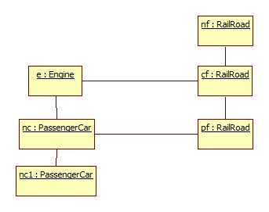

Collide Trains

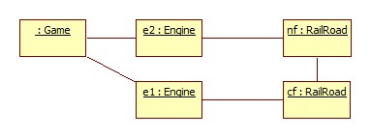

Arrive to Station

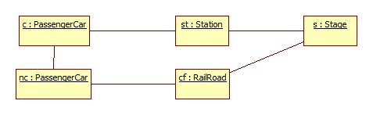

Activate Tunnel
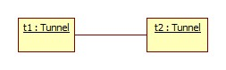

Deactivate Tunnel

Enter Tunnel
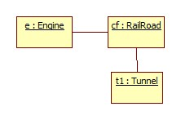

Control Switch

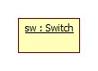

Pass Switch
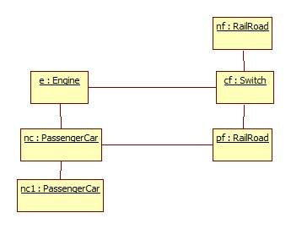

Plans of the skeleton’s UI, dialogs

“ => ” method call
“ <= “ return
“ ? “ decision point (user input)
[variable name:Class name]

Command #1 - “Move Train”
=> [e:Engine].move()
=> [cf:RailRoad].getDirection()
<= [nf:Railroad]
=> [cf:Railroad].removeCar()
<= void
=> [nf:Ralroad].acceptCar(e, cf)
<= void
=> [nc:PassangerCar].moveTo(cf)
=> [pf:RailRoad].removeCar()
<= void
=> [cf:RailRoad].acceptCar(nc, pf)
<= void
=> [nc1:PassangerCar].moveTo(pf)
<= void
<=
<=

Command #2 - “Collide Trains”
=> [e1:Engine].move()
=>[cf:RailRoad].getDirection()
<= [nf:RailRoad]
=>[nf:RailRoad].acceptCar(e,cf)
? Is There another engine on the “nf” field? (Yes/NO): Yes
=>[e1:Engine].collide()
=>[q:Game].endGame()
<=void
<=void
<=void
<=void

Command #3 - “Arrive to Station”
=> [c:PassangerCar].moveTo(st)
=> [st:Station].acceptCar(pc, cf)
=> [c:PassengerCar].setField(st)\
<= void
=> [c:PassengerCar].removePassenger(st)
? Is "c" active? (Yes/NO): Yes
=> [c:PassengerCar].activateNextCar()
=> [nc:Car].activate()
<= void
<= void
<= void
=> [s:Stage].passengerDelievered()
<= void
<= void
<= void

Command #4 - “Activate Tunnel”
=> [t1:Tunnel].activate()
=> [t2:Tunnel].activate()
<= void
<= void

Command #5 - “Deactivate Tunnel”

=> [t1:Tunnel].deactivate()
=> [t2:Tunnel].deactivate()
<= void
<= void

Command #6 - “Enter Tunnel”
=> [e:Engine].move()
=> [t1:Tunnel].acceptCar(c, cf)
=> [e:Engine].setField(t1)
<= void
=> [e:Engine].setInvisible()
<= void
<= void
<= void

=> [e:Eingine].move()
=> [cf:RailRoad].getDirection()
<= [t2:Tunnel]
=> [cf:RailRoad].removeCar()
<= void
=> [t2:Tunnel].acceptCar(c, t1)
=> [e:Engine].setField(t2)
<= void
=> [e:Engine].setVisible()
<= void
<= void
<= void

Command #7 - “Control Switch”
=> [sw:Switch].changeDirection()
<= void
<= void

Command #8 - “Pass Switch”
=> [e:Engine].move()
=>[cf:Switch].getDirection()
<= [nf:RailRoad]
=> [cf:Switch].removeCar()
<= void
=> [nf:RailRoad].acceptCar(e, cf)
<= void
=> [nc:PassengerCar].moveTo(cf)
=> [pf:RailRoad].removeCar()
<= void
=> [cf:Switch].acceptCar(nc, pf)
<= void
=> [nc1:PassengerCar].moveTo(pf)
<= void
<= void
<= void

Detailed sequence diagrams for internal activities

Move Train
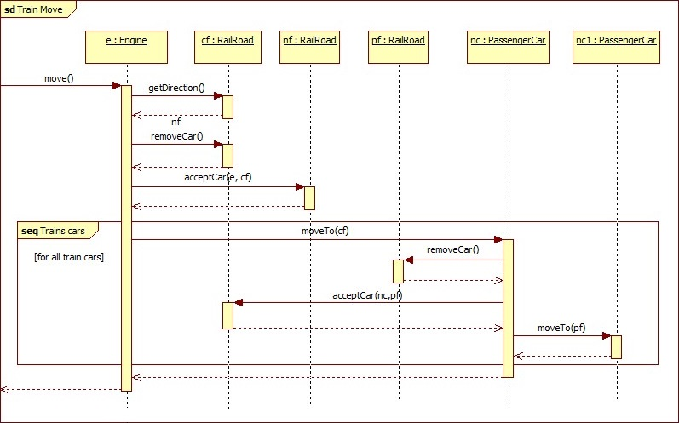

Collide Trains
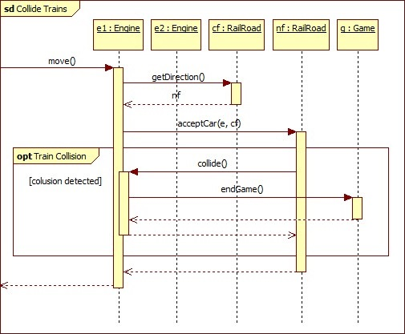

Arrive to Station
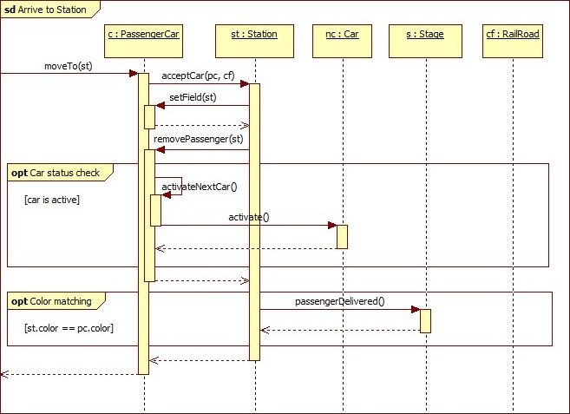

Activate Tunnel
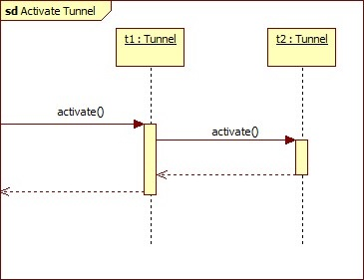

Deactivate Tunnel
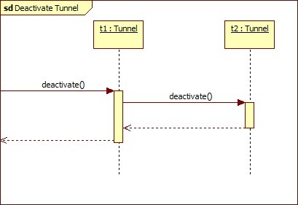

Enter Tunnel

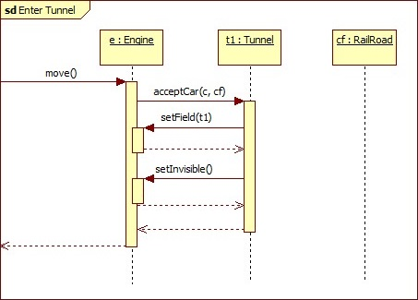

Control Switch
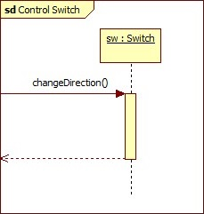

Pass Switch

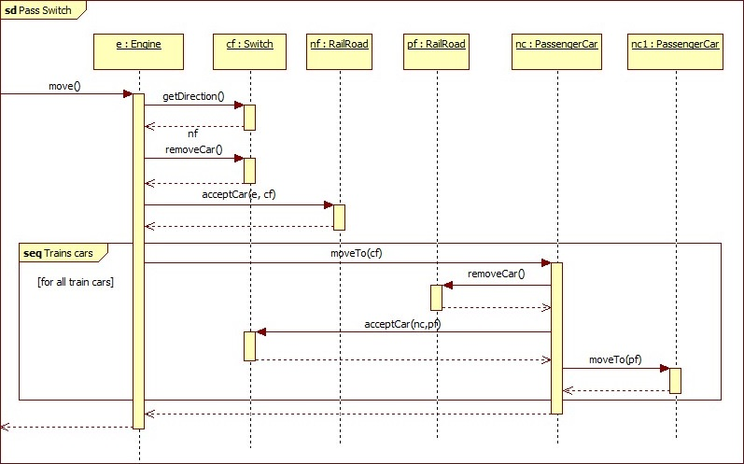

Protocol

Start (date & time) | Duration (hours) | Performer(s) name | Activity description
05.03.2019 10:00 | 2 hours | Irakli Vashakidze, Mikheil Tabidze, Shota Osepashvili | Consultation with course lecturer Dr. Katalin Balla
07.03.2019 16:30 | 1 hour | Irakli Vashakidze, Mikheil Tabidze, Shota Osepashvili | Meeting. Decisions:  Irakli Vashakidze is responsible for the preparing 5.3 Plans of the skeleton’s UI, dialogs, the deadline is 09.03.2019  Mikheil Tabidze is responsible for the preparing 5.2 Architecture, the deadline is 09.03.2019  Shota Osepashvili is responsible for the preparing 5.1 Real use-cases of the skeleton model, the deadline is 09.03.2019
08.03.2019 12:00 | 1 hour | Irakli Vashakidze, Mikheil Tabidze, Shota Osepashvili, Yasir M. Suliman A., Yekaterina Ussacheva | Meeting. Decisions  Yasir M. Suliman A. is responsible for the preparing 5.4 Detailed sequence diagrams for internal activities Part 1, the deadline is 09.03.2019  Yekaterina Ussacheva is responsible for the preparing 5.4 Detailed sequence diagrams for internal activities Part 2, the deadline is 09.03.2019
09.03.2019 10:00 | 3 hours | Irakli Vashakidze | Preparing 5.3 Plans of the skeleton’s UI, dialogs
09.03.2019 12:00 | 3 hours | Mikheil Tabidze | Preparing 5.2 Architecture
09.03.2019 10:00 | 3 hours | Shota Osepashvili | Preparing 5.1 Real use-cases of the skeleton model
09.03.2019 18:00 | 3 hours | Yasir M. Suliman A. | Preparing 5.4 Detailed sequence diagrams for internal activities Part 1
09.03.2019 14:00 | 3 hours | Yekaterina Ussacheva | Preparing 5.4 Detailed sequence diagrams for internal activities Part 2
11.03.2019 10:00 | 0.5 hour | Irakli Vashakidze, Mikheil Tabidze, Shota Osepashvili, Yasir M. Suliman A., Yekaterina Ussacheva | Meeting. Submission of 5. Planning the skeleton

